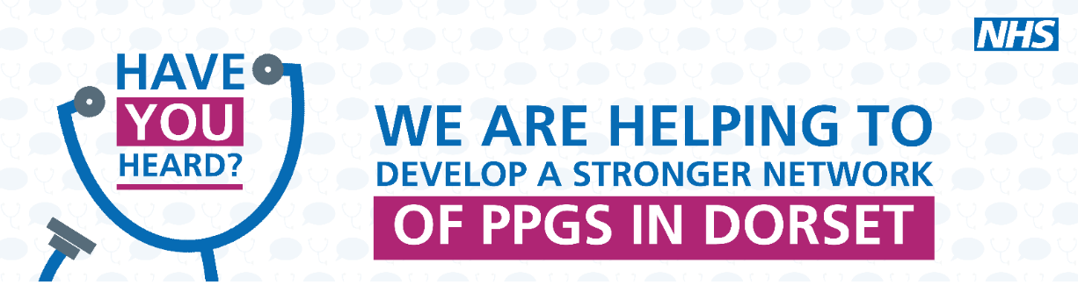
Bridges Patient Participation Group (PPG)
23 February 2023
Zoom

Notes of Meeting
 |  | Action
1 | Welcome and apologies  Present: Sue Brunt (Chair), Dr Rupert Turberville-Smith, Lennie Edwards, Jim Gammans (ICB), GP, IU, MP, FK, TB, SP, JC, SE, PO, JW, MC, GC, SB, CB, LO, AR, BB  Apologies: NW  Sue welcomed everyone to the meeting particularly the new members. She will email them the terms of reference for the group.
2 | Actions from the last meeting  LO is now receiving texts with the link to the newsletter.
3 | Surgery update  Park run –  The practice is now a registered Park Run Practice. We are encouraging patients to join the Saturday morning 5K run / walk which some staff members attend. There is no pressure to go at a particular pace and all abilities go. There are posters in the waiting room advertising it and it was included in the last newsletter.  Veteran Friendly–  The practice is now also registered as Veteran Friendly. This means that the clinicians have had training on what potential physical and mental health problems to consider for veterans that may be as a result of their time in the forces. We also make the hospital aware the patient is a veteran if they are being referred.  PO said there is a veterans hub in Wyke.  Staff Changes –  Dr Nick Luscombe has left the practice. We are recruiting and will hopefully have good news at the next meeting.  A new Nurse has been appointed.  CQC –  The practice is really pleased that we achieved a rating of Good after the inspection in November. Lennie thanked Sue for being interviewed. Sue congratulated the practice and said if there is anything in the report that the PPG can help with then to let her know.  Strep A-  The practice was the busiest it has ever been during the Strep A outbreak with Drs working late into the evening in order to see everyone. During that time the phone message was updated to point parents to the Healthier Together website which gives easy to understand advice on when to watch and wait, when to see a GP and when to go to A&E. It covers lots of childhood illnesses (not just Strep A).  The phone message has since been amended to ask all patients requesting an urgent appointment to go to NHS 111 Online or the Healthier Together website 1st. If possible, we need to be able to reduce our urgent appointments in order to provide more routine appointments.  Extended Access –  The PCN (Primary Care Network) has started to offer Saturday morning appointments. These are located in different surgeries across Weymouth and Portland but can be jointly used by all the surgeries. Therefore, Bridges patients may be offered an appointment at a different surgery. The clinician will have access to our records.  These appointments are in addition to our appointments – they do not replace what we already offer. | PO to send info on the veterans hub to be included in a future newsletter
4 | Website  Options for a new website were circulated before the meeting and Sue asked if anyone had any thoughts / suggestions.  LO – was surprised that the 1st thing a lot of them show is information for new patients. She thinks it should be appointments and contact information should be prominent. Patients don’t want to know about job vacancies. Her preference is College Lane and Bountfield. Definitely not Garden City. Simplicity is important with a plain background.  MP – agreed with LO. Less is more.  JC – likes Charlotte Keels and Basingham. Liked that they show what days the Drs work. We need to ensure the website is checked for accessibility – Jim said he thinks the provider has already done this.  TB – likes Charlotte Keels.  FK – likes College Lane. Thinks there should be links to other services.  JW said she wanted a search option which the new websites have. She would like it to be simple with large print.  SE said that Cross Rd surgery have an app.  Sue would like the PPG to more prominent on the new website than it currently is.  Lennie thanked everyone for their feedback which will be taken into consideration. It was agreed that the front page should be simple but with the option for patients to access more pages with further information.
5 | Projects  Digital Volunteers –  The Digital Volunteers are at The Bridges Tues AMs and Littlemoor 2nd / 4th Tues PMs. They are now working in all the Weymouth and Portland Surgeries. In 6 months, they have helped over 600 patients of which 272 are registered at The Bridges. They are now helping patients to sign up to the BP app as well.  SE said that the WiFi at Littlemoor is appalling. | LE to ask for the WiFi at Littlemoor to be improved
6 | Newsletter  The last one came out in January. Sue liked the data section. There are still too many DNAs (Did Not Attend). The time isn’t wasted as the clinicians find other work to do but they put pressure on the appointment system (some appointments are 30 minuites).  CB suggested surveying patients who DNAd to try and find out why. | LE to produce a survey to send to patients
7 | AOB  BB said that she found the receptionists obstructive although the Drs are very helpful.  Lennie explained that the receptionists are doing what they are asked by the practice and unfortunately don’t have enough appointments to be able offer patients what they would like. If a Dr adds patients to the end of their clinic then that’s their decision but the receptionists aren’t allowed to do so.  Dr Turberville-Smith said it’s easier for the Drs to manage their own workload but there are lots of different clinicians who do different things and the receptionists have to know each of their criteria. They have a very difficult job. We know things don’t always go right for everyone, but we try our best.  TB, GP and MP said they think the receptionists are excellent.
Close
There wasn’t enough time to discuss all the agenda items so the remaining ones will be carried forward to the next meeting which will be in 6 – 8 weeks.

The group voted for the next meeting to be face to face.

